
wCarlinville Intermediate School

We are CIS
Kyle Smith, Principal
Lori Reiher, Counselor

Phone: 217/854-9523
Fax: 217/854-3417
Be Kind, Nice, & Thoughtful

“News From the Office”

Hello CIS Families,  The second quarter is off to a busy start! We want to thank our CIS families who joined us for Parent Teacher Conferences. As we look towards the holidays, we know things are bound to get even busier. We will send home Skylerts and reminders as much as possible. Please make sure to check skyward that your correct contact information is in the system. Also, to receive the text, phone calls and emails, those must be selected also. If you have any questions, please feel free to reach out to the office at 217-854-9523. You can also stay connected to CIS with our website, https://cusd1.com/, and select Carlinville Intermediate or by using the Remind app to communicate with your student’s teacher.  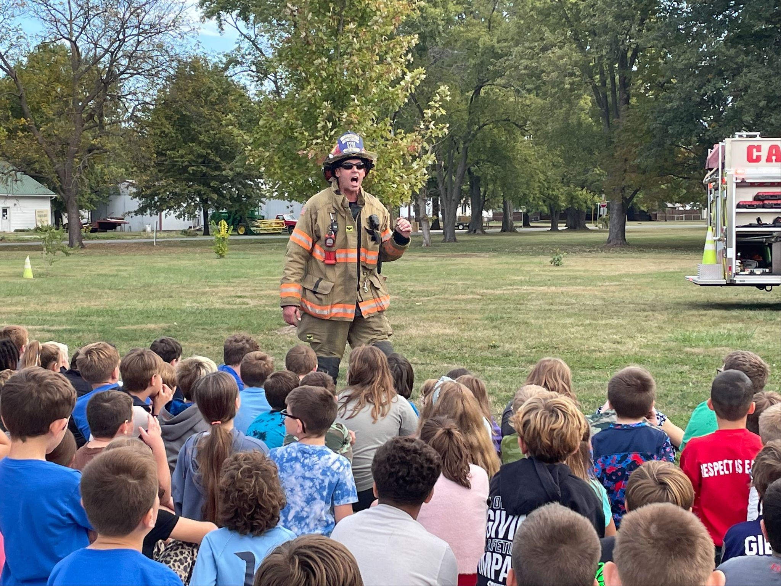  Fire Prevention Week: A Recap  We would like to give a huge shout out of appreciation to the Carlinville Fire Department Department, Davis Towing and BJ Vinyard for our Fire Safety Assembly. The students learned about different tools and equipment the department has, they watched demonstrations on putting fires out and even cutting through metal. CIS looks forward to the assembly every year! Thank you again to our wonderful fire department!!  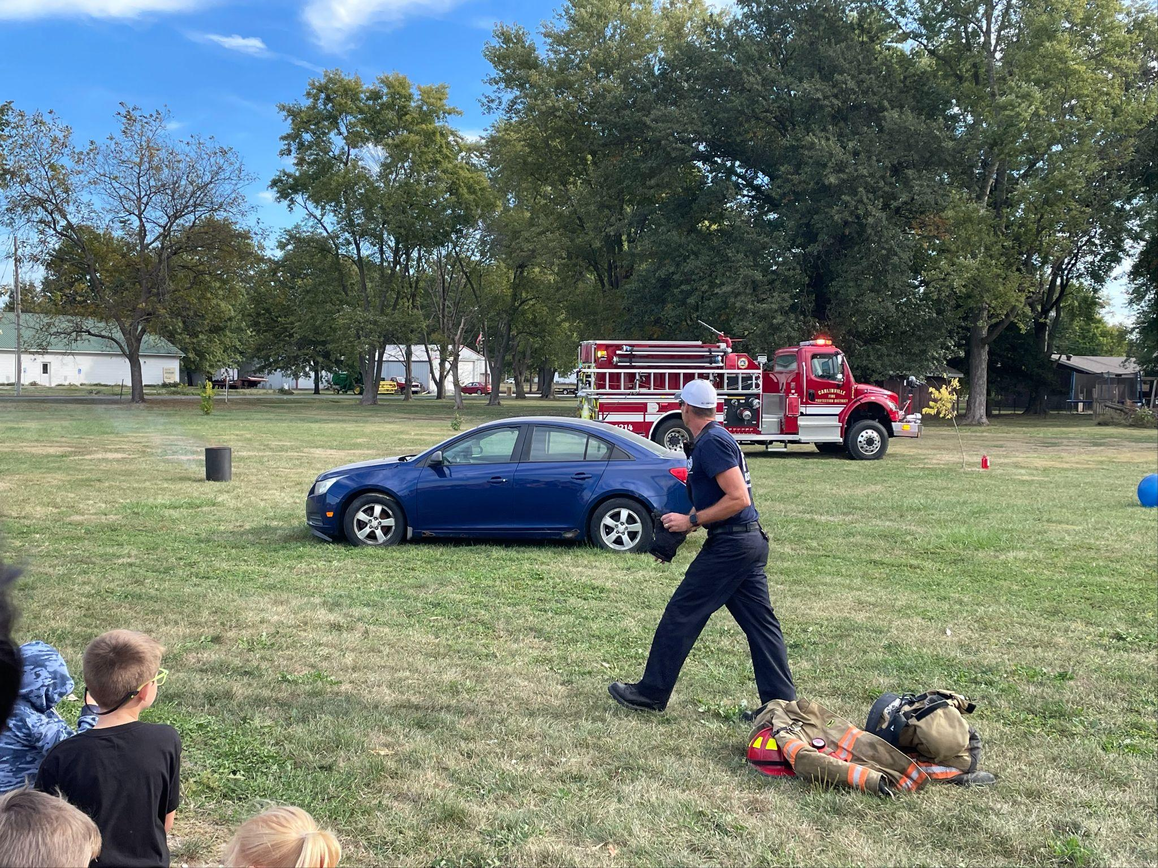  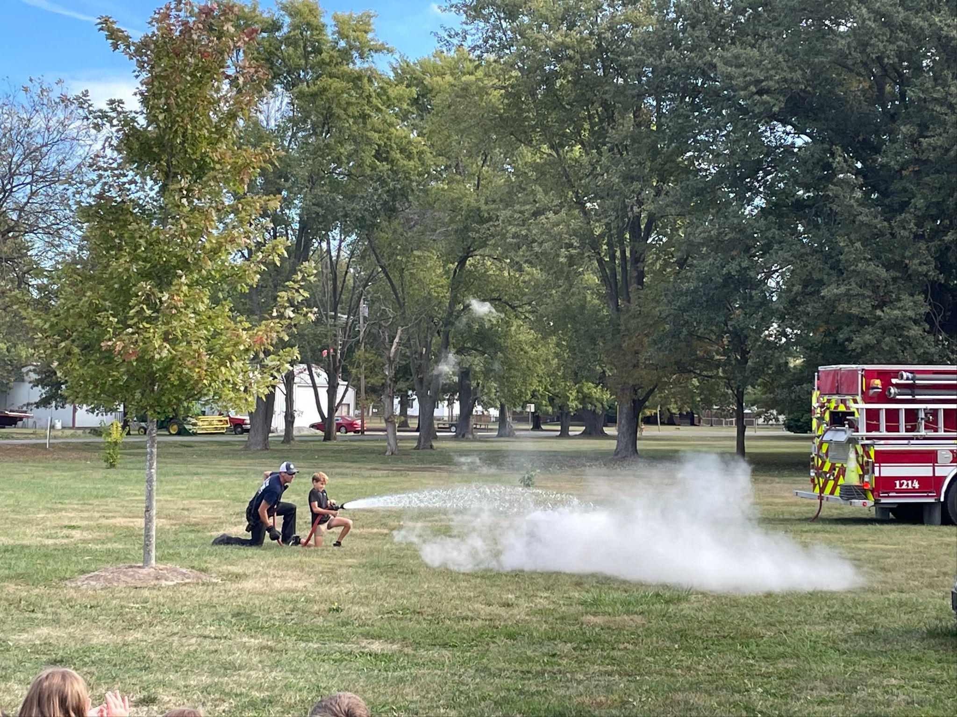  We Love our First Responders    A Note from the Principal-Teamwork is Success  "Coming together is a beginning. Staying together is progress.  And working together is success." — Henry Ford  Whether it is a sports team, band, office staff, or community group, working together not only leads to success, but in the words of Henry Ford-it IS success. One of the greatest life skills we can promote with our students is the ability to work with others toward a common goal. This is easier said than done; anytime you put a group of kids together, there is going to be disagreements, conflicts, and various other obstacles that prohibit them working together. It is easy to throw up our hands and say “No More!” However, it is so important to say “Yes, More!” and help our kids learn how to work together in spite of all the road blocks. If students can learn to work with others effectively they are being successful and will continue to be successful moving forward. Teamwork promotes balance, increases productivity, unleashes innovation, and yields solutions. Teamwork isn’t just about reaching goals-Teamwork is the Goal..  CIS Artwork is Headed to College!    We are thrilled to share some exciting news— throughout the 25-26 school year, we will be partnering with Blackburn College to highlight and celebrate the creativity, effort, and imagination of our students in art class. Each month, selected CIS student artwork will be displayed at Blackburn College - Demuzio Center Bookstore in a special exhibit.  Transportation MEMO  Special ride requests are not allowed. The buses are already at maximum capacity. Students must ride on the buses they were assigned at the beginning of the school year. During registration, the bus routes are determined based on the legal amount of students we can have per bus. Thank you for your understanding.    Cold Weather Attire  The weather is changing and coats will be in order. Please make certain your child is dressed to play outside. We go outside as much as possible throughout the winter months and need all the students to be outfitted so that they are not cold. It is also important to put your child’s name in their items in the event they are lost. We are beginning to have a collection of hoodies and jackets that have been placed in lost and found.  Guidance Notes from Mrs. Reiher  In November, the CIS Character Theme is Teamwork. Students will learn what a “dream team” looks like, sounds like, and feels like. Mrs. Reiher will also teach a unit on home alone safety and personal safety. Please contact the office if you have any questions or concerns.  Thanks to all the students who took the Red Ribbon Week pledge. We pledged to make safe and healthy choices. Thanks to all who entered the coloring contest and the essay contest!!  Nurses Corner  Miles of Smiles will be at CIS on November 5th and 6th. Please reach out if you missed the signup and would like your child to see the dentist.  All medications given in school, including non-prescription drugs (i.e. Tylenol, Ibuprofen), requires an order by a licensed prescriber. It is the parent(s) or guardian's responsibility to ensure that the licensed prescriber’s order, written request and medication are brought to the school. Please ensure all portions of the medication form are completed.  *All Health forms can be found on the district site under;  Resources - Medical Forms  Absences and Medical Excuses  As we enter further into the school year, we want to remind parents and families the district and state requirements regarding student absences. A student who misses more than 10% of the school year (18 days) will be identified as a Chronic Absentee student. Students who miss more than 5% of the school year (9 days) without a valid cause will be identified as Chronic Truant. If a student’s absences are due to medical appointments (doctor, dentist, orthodontist, etc.), the absence will not count towards the above total if the student brings a medical excuse from the doctor. Please submit all medical excuses to the office in a timely manner.  We hope you have a great Thanksgiving! | Key Dates:  Nov. 5th-6th  Dental Clinic  Nov. 11th  No School  Veteran’s Day  Nov. 20th  Little Italy’s Pizza  Nov. 24th  4th Grade Field Trip  St Louis Science Center  Nov. 26th-28th  No School  Thanksgiving Holiday  Dec. 8th-12th  Holiday Shop at CIS  Dec. 17th  Christmas Concert  Dec. 22nd -Jan. 5th  No School  Christmas Break    CIS Character Theme for November  Teamwork  “Work together to reach a goal”    If there are any school closures, you will get a call through Skylert. Please make sure your contact info is updated in Skyward.
 | 

