
Carlinville Intermediate School

Fax: 217/854-3417
Phone: 217/854-9523
Kyle Smith, Principal
Lori Reiher, Counselor
Lydia Miller, Nurse
“News From the Office”

As we return from Thanksgiving break, we will hit the ground running with December activities that are sure to keep us busy through the end of our second semester. We have updated the Key Dates section to the right and also added the Dress Up Days Calendar to the bottom of the newsletter.  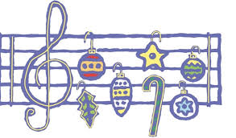  Christmas Concert - One of the most enjoyable events each year at Carlinville Intermediate School is the Christmas Concert! Mr. White will have a concert for each grade on December 17th. 3rd grade will be at 9, 4th grade at 10:30 and 5th grade will begin at 1. There will be a shuttle from City Hall starting 30 minutes before each concert. We ask that family members do not arrive more than 30 minutes prior to the concert to alleviate congestion in the hallways and parking lot. The concert will be held in the gym and the gym lobby doors will be open for you to enter through.  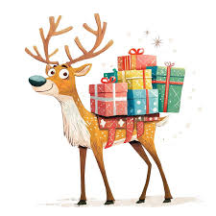  Holiday Shop  The CIS Holiday shop is returning again this year. The students really enjoy shopping for their family and friends. You can preview the shop items with your student at http://9526230.holidaytreasures.com/. We will be sending home information on what day your child’s class will be shopping. Parents can buy gift vouchers for their students instead of sending cash or a check this year. Check the website for more info.  If you’d like to volunteer to help our shoppers, please sign up with using this link:  https://www.signupgenius.com/go/70A0E49A5AE23A5FE3-60754306-holiday  Reminder! It is Coat, Hat and Gloves Season!! Please make certain your child is dressed to play outside. We go outside as much as possible throughout the winter months and need all the students to be outfitted so that they are not cold. It is also important to put your child’s name in their items in the event they are lost.  Guidance Notes from Mrs. Reiher:  Responsibility is the character trait for December. Mrs. Reiher’s guidance lessons will focus on taking ownership of our thoughts, words, and actions. Kids will learn the importance of taking responsibility for their jobs at school as well as learn how to apologize appropriately.  Nurses Corner  December is busy and illness is on the rise!! Make sure your student(s) are eating properly and getting plenty of rest. Reminder to keep your student home for 24 hours following vomiting, diarrhea, and fever.  Carlinville is blessed to have several programs helping families during the Christmas season. Just a reminder if you signed up for an Elk’s basket, delivery is Saturday, December 20th from 8 to 10 a.m. The Federated Church Shopping Spree is Dec 13th and 14th. Shopping spree day and times will be sent home the week prior. A lot of hard work and time is spent making these opportunities possible. Please encourage or help your students to write thank you notes to whoever makes their holiday special this year!! | Key Dates:  Dec. 5th  All Library Books Need Returned  Dec. 8th-12th  Holiday Shop  Dec. 12th  Sleigh Into the Holidays w/ CHS  Dec. 17th  Christmas Concerts  Dec. 19th  Christmas Parties  @ 2:00  Dec. 22nd - Jan. 5th  No School  Christmas Break  Jan. 6th  Students Return  Jan. 9th  Report Cards  Issued  
